Practical 11

Part A:
Aim:
1. Save/load: make a small class Serializable, save an array of its objects to a file with ObjectOutputStream, then read it back into fresh objects and confirm the values survived.
Mark one field transient and show it is not saved.

Code:
Student.java
import java.io.Serializable;

public class Student implements Serializable {

private static final long serialVersionUID = 1L;

private int id;
private String name;
private double marks;

// This field will not be serialized
private transient String sessionToken;

public Student(int id, String name, double marks,
String sessionToken) {
this.id = id;
this.name = name;
this.marks = marks;
this.sessionToken = sessionToken;
}

@Override
public String toString() {
return "Student{id=" + id
+ ", name='" + name
+ "', marks=" + marks
+ ", sessionToken=" + sessionToken + "}";
}
}

SaveLoadDemo.java
import java.io.FileInputStream;
import java.io.FileOutputStream;
import java.io.ObjectInputStream;
import java.io.ObjectOutputStream;
import java.io.IOException;

public class SaveLoadDemo {

public static void main(String[] args) {

String filename = "students.ser";

Student[] students = {
new Student(101, "Riya", 91.5, "TOKEN-A"),
new Student(102, "Aman", 85.0, "TOKEN-B"),
new Student(103, "Sara", 88.5, "TOKEN-C")
};

// Save the object array
try (ObjectOutputStream out =
new ObjectOutputStream(
new FileOutputStream(filename))) {

out.writeObject(students);
System.out.println("Objects saved successfully.");

} catch (IOException e) {
System.out.println("Error saving objects: " + e.getMessage());
return;
}

// Read the object array into fresh objects
try (ObjectInputStream in =
new ObjectInputStream(
new FileInputStream(filename))) {

Student[] restored = (Student[]) in.readObject();

System.out.println("\nRestored objects:");

for (Student student : restored) {
System.out.println(student);
}

} catch (IOException | ClassNotFoundException e) {
System.out.println("Error loading objects: " + e.getMessage());
}
}
}

Output:
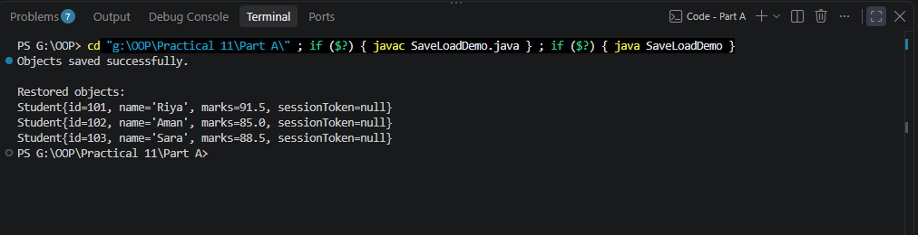
2. Log analyzer: create a few text files, then use Path/Files to read each line by line and count the total lines and how many contain a keyword across all files; also print each file’s size from its attributes.

Code:
LogAnalyzer.java
import java.io.BufferedReader;
import java.io.IOException;
import java.nio.charset.StandardCharsets;
import java.nio.file.Files;
import java.nio.file.Path;
import java.nio.file.Paths;
import java.util.List;

public class LogAnalyzer {

public static void main(String[] args) {

Path directory = Paths.get("logs");
String keyword = "error";

try {
// Create a directory for sample logs
Files.createDirectories(directory);

// Create three sample files
Files.write(
directory.resolve("app1.txt"),
List.of(
"INFO Application started",
"ERROR Database connection failed",
"INFO Retry successful"
),
StandardCharsets.UTF_8
);

Files.write(
directory.resolve("app2.txt"),
List.of(
"INFO User logged in",
"WARNING Low memory",
"ERROR File not found",
"INFO Application stopped"
),
StandardCharsets.UTF_8
);

Files.write(
directory.resolve("app3.txt"),
List.of(
"INFO Server started",
"INFO Request processed"
),
StandardCharsets.UTF_8
);

} catch (IOException e) {
System.out.println("Could not create sample logs: "
+ e.getMessage());
return;
}

long totalLines = 0;
long matchingLines = 0;

try (var files = Files.list(directory)) {

for (Path path : files.filter(Files::isRegularFile)
.sorted()
.toList()) {

long fileLines = 0;
long fileMatches = 0;

try (BufferedReader reader =
Files.newBufferedReader(
path, StandardCharsets.UTF_8)) {

String line;

while ((line = reader.readLine()) != null) {
fileLines++;

if (line.toLowerCase()
.contains(keyword.toLowerCase())) {
fileMatches++;
}
}
}

long size = Files.size(path);

totalLines += fileLines;
matchingLines += fileMatches;

System.out.println("File: " + path.getFileName());
System.out.println("Size: " + size + " bytes");
System.out.println("Lines: " + fileLines);
System.out.println("Keyword matches: " + fileMatches);
System.out.println();
}

} catch (IOException e) {
System.out.println("Error analyzing logs: " + e.getMessage());
return;
}

System.out.println("=== Overall Summary ===");
System.out.println("Total lines: " + totalLines);
System.out.println("Lines containing '" + keyword
+ "': " + matchingLines);
}
}

Output:
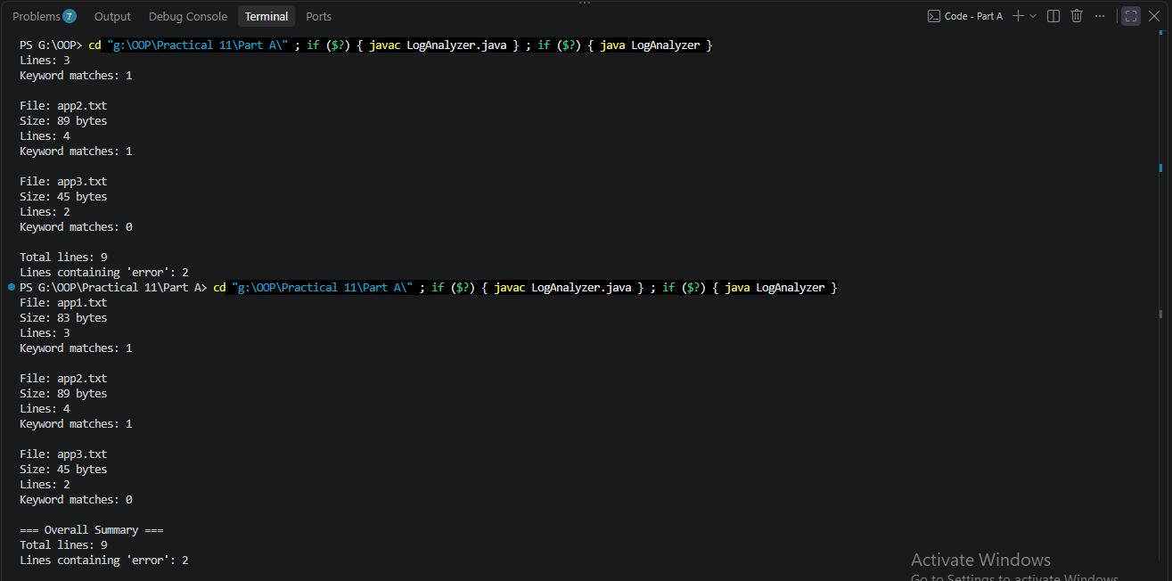

3. (For Advanced Learners – home) Walk a folder tree with NIO and produce a report of the files it contains (name, size, modified time), writing the summary to a file; decide what to include.

Code:
FileTreeReport.java
import java.io.IOException;
import java.nio.charset.StandardCharsets;
import java.nio.file.FileVisitResult;
import java.nio.file.Files;
import java.nio.file.Path;
import java.nio.file.Paths;
import java.nio.file.SimpleFileVisitor;
import java.nio.file.attribute.BasicFileAttributes;
import java.time.Instant;
import java.util.ArrayList;
import java.util.List;

public class FileTreeReport {

public static void main(String[] args) {

Path root = Paths.get("sample-tree");
Path report = Paths.get("file-report.txt");

// Create sample directory structure
try {
Files.createDirectories(root.resolve("documents"));
Files.createDirectories(root.resolve("images"));

Files.writeString(
root.resolve("readme.txt"),
"This is a sample file.",
StandardCharsets.UTF_8
);

Files.writeString(
root.resolve("documents/notes.txt"),
"Java NIO practice.",
StandardCharsets.UTF_8
);

Files.writeString(
root.resolve("images/info.txt"),
"Sample image directory.",
StandardCharsets.UTF_8
);

} catch (IOException e) {
System.out.println("Could not create sample tree: "
+ e.getMessage());
return;
}

List<String> reportLines = new ArrayList<>();
long[] totals = new long[2];
// totals[0] = file count
// totals[1] = total size in bytes

reportLines.add("FILE TREE REPORT");
reportLines.add("Root: " + root.toAbsolutePath());
reportLines.add("");

try {
Files.walkFileTree(root, new SimpleFileVisitor<Path>() {

@Override
public FileVisitResult visitFile(
Path file,
BasicFileAttributes attrs) {

if (attrs.isRegularFile()) {
String fileName = file.getFileName().toString();
String relativePath = root.relativize(file).toString();
long size = attrs.size();
Instant modified = attrs.lastModifiedTime()
.toInstant();

String entry = String.format(
"Name: %s | Path: %s | Size: %d bytes"
+ " | Modified: %s",
fileName,
relativePath,
size,
modified
);

reportLines.add(entry);

totals[0]++;
totals[1] += size;
}

return FileVisitResult.CONTINUE;
}

@Override
public FileVisitResult visitFileFailed(
Path file,
IOException exc) {

reportLines.add(
"Could not access: " + file
+ " | Reason: " + exc.getMessage()
);

return FileVisitResult.CONTINUE;
}
});

reportLines.add("");
reportLines.add("=== SUMMARY ===");
reportLines.add("Total files: " + totals[0]);
reportLines.add("Total size: " + totals[1] + " bytes");

Files.write(
report,
reportLines,
StandardCharsets.UTF_8
);

System.out.println("Report generated: "
+ report.toAbsolutePath());
System.out.println("Total files: " + totals[0]);
System.out.println("Total size: " + totals[1] + " bytes");

} catch (IOException e) {
System.out.println("Error generating report: "
+ e.getMessage());
}
}
}

Output:
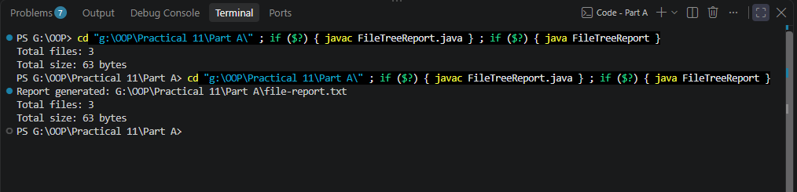
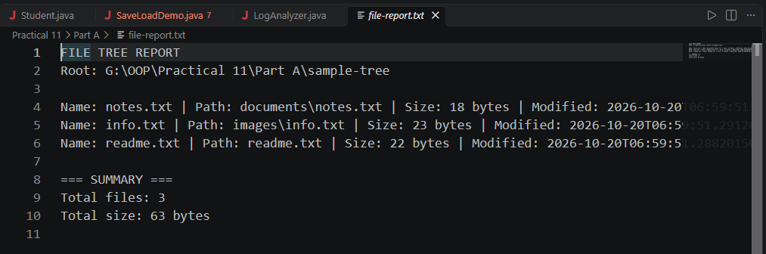

Key Questions / Analysis / Interpretation to be evaluated during/after Implementation

1. What does it mean for a class to be Serializable, and why add serialVersionUID?

Ans.
A class is Serializable when it implements Java's Serializable interface, allowing its objects to be converted into a byte stream and saved or transferred for later reconstruction.
Example from Student.java:
import java.io.Serializable;

public class Student implements Serializable {

private static final long serialVersionUID = 1L;

private int id;
private String name;
private transient String sessionToken;
}
How it works:
- ObjectOutputStream serializes the object's state into a file.
- ObjectInputStream reads the serialized data.
- Java reconstructs the object with its saved field values.
The Serializable interface is a marker interface: it declares no methods.
Why use serialVersionUID?
private static final long serialVersionUID = 1L;
It identifies the version of a serializable class. During deserialization, Java checks the stored identifier against the class's identifier. If they are incompatible, deserialization can fail with InvalidClassException.
What does transient do?
private transient String sessionToken;
It excludes the field from default serialization. After deserialization, the field receives its default value—in this case, null.

2. What is the difference between a byte stream and a character stream?

Ans.
Byte Stream | Character Stream
Processes raw bytes. | Processes text characters.
Commonly used for binary data, such as images and serialized objects. | Used for text files and character data.
Base classes include InputStream and OutputStream. | Base classes include Reader and Writer.
Examples: FileInputStream, FileOutputStream. | Examples: FileReader, FileWriter, BufferedReader.

3. How does NIO’s Path/Files API differ from the old File class, and how is a directory stream iterated?

Ans.
File class | NIO Path / Files API
Represents a file or directory path. | Path represents a path; Files provides filesystem operations.
Provides basic methods such as exists(), delete(), and mkdir(). | Provides richer operations such as readString(), copy(), move(), and walkFileTree().
Some operations return only a boolean, offering limited error details. | Many operations throw IOException, providing more informative error handling.
Directory listing commonly uses list() or listFiles(). | Directory iteration can use Files.list() and DirectoryStream.

A DirectoryStream<Path> lets you iterate over entries directly inside a directory.
import java.io.IOException;
import java.nio.file.DirectoryStream;
import java.nio.file.Files;
import java.nio.file.Path;
import java.nio.file.Paths;

Path directory = Paths.get("logs");

try (DirectoryStream<Path> stream =
Files.newDirectoryStream(directory)) {

for (Path entry : stream) {
System.out.println(entry.getFileName());
}

} catch (IOException e) {
System.out.println("Error: " + e.getMessage());
}

The for loop visits each entry, and try-with-resources automatically closes the directory stream.

